**Beerrecepies**

**Project Report:**

A Comprehensive Analysis of a Recipe Searching Website

* **Project Title: Beerrecepies A Recipe Searching Website**
* Website name: **Beerrecepies**
* Project Tagline: "Discover and Share Delicious Recipes"
* Author: Piyush Kumar
* Date: [Submission Date]

### 1. Abstract

The "Beerrecepies" project is a web-based platform aimed at providing users with a comprehensive and user-friendly interface for discovering and exploring a diverse range of beer-related recipes. Leveraging HTML, CSS, and JavaScript, alongside integration with TheMealDB API, the platform offers users an extensive database of beer-infused recipes to suit various tastes and preferences.

The project focuses on delivering key features such as robust recipe search functionality, detailed recipe information display, and responsive design to ensure optimal user experience across different devices. Through iterative development and testing, the BeerEcipes platform aims to inspire culinary exploration, creativity, and enjoyment among beer enthusiasts and homebrewers worldwide.

This report provides a detailed overview of the project, including its objectives, scope, implementation details, testing methodologies, challenges faced, future enhancements, and conclusions. By analyzing the development process and outcomes, this report aims to showcase the value and potential impact of the BeerEcipes platform in the culinary and brewing community.

**2. Table of Contents**

1. Introduction
2. Project Objectives
3. Project Scope
4. System Analysis
   * 4.1 Requirement Analysis
5. System Design
   * 5.1 User Interface Design
6. Implementation
   * 6.1 Technology Stack
   * 6.2 Code Structure
   * 6.3 Key Features
7. Testing
   * 7.1 Test Plan
   * 7.2 Test Cases
   * 7.3 Testing Tools
   * 7.4 Results
8. Deployment
   * 8.1 Deployment Environment
   * 8.2 Deployment Steps
9. User Manual
   * 9.1 How to Use the Website
   * 9.2 Screenshots and Descriptions
10. Challenges and Solutions
11. Future Enhancements
12. Conclusion
13. References

**3. Introduction**

**Overview:**

The Recipe Searching Website is a dynamic and interactive web application designed to help users discover and explore a wide variety of recipes. Built using HTML, CSS, and JavaScript, this website leverages the power of TheMealDB API to fetch and display recipes from a vast database. The goal of the project is to provide an easy-to-use platform where users can search for recipes based on ingredients, categories, or cuisines, and view detailed information about each recipe, including ingredients, instructions, and images.

**Key Features:**

1. **Recipe Search Functionality:**
   * Users can search for recipes by name, ingredients, or category.
   * Real-time search results are fetched and displayed as the user types.
2. **Recipe Details Page:**
   * Upon selecting a recipe, users can view detailed information including ingredients, preparation steps, and images.
   * The detailed view also includes nutritional information and cooking tips.
3. **Responsive Design:**
   * The website is designed to be fully responsive, ensuring a seamless experience across various devices such as desktops, tablets, and smartphones.
4. **User-Friendly Interface:**
   * Clean and intuitive layout with easy navigation.
   * Visual appeal enhanced by CSS styling, making the user experience engaging and enjoyable.

**Technologies Used:**

* **HTML:** Provides the structure and layout of the web pages.
* **CSS:** Used for styling the website, ensuring it is visually appealing and responsive.
* **JavaScript:** Handles the dynamic aspects of the website, including API requests, data handling, and DOM manipulation.
* **TheMealDB API:** A third-party API used to fetch recipe data, including names, ingredients, instructions, and images.

**Purpose and Significance:**

The Recipe Searching Website aims to simplify the process of finding and trying new recipes, catering to food enthusiasts, home cooks, and anyone looking to diversify their culinary skills. By utilizing TheMealDB API, the website offers a vast collection of recipes, ensuring that users can find dishes that match their preferences and dietary requirements.

**Target Audience:**

The website is designed for:

* Home cooks looking for new recipes to try.
* Food enthusiasts eager to explore different cuisines.
* Individuals seeking recipes based on available ingredients.
* Anyone interested in cooking and learning new culinary techniques.

This project combines modern web development practices with an external API to deliver a functional and attractive recipe searching platform, demonstrating both technical skills and an understanding of user experience design.

**4. Project Objectives**

**Main Objectives of Creating the Website:**

1. **Enhance Culinary Exploration:**
   * Provide a platform for users to discover a wide variety of recipes from different cuisines around the world.
2. **Simplify Recipe Search:**
   * Enable users to easily search for recipes based on ingredients, categories, or specific dishes.
3. **Improve User Experience:**
   * Design an intuitive and visually appealing interface that makes it easy for users to navigate and find recipes.
4. **Promote Healthy Eating:**
   * Offer detailed nutritional information to help users make informed choices about their meals.
5. **Leverage Modern Web Technologies:**
   * Utilize HTML, CSS, and JavaScript to build a dynamic and responsive website that performs well across different devices.

**Specific Goals to be Achieved:**

1. **Integrate TheMealDB API:**
   * Successfully implement API calls to fetch and display recipe data, ensuring real-time updates and accurate information.
2. **Develop Advanced Search Features:**
   * Implement a robust search functionality that allows users to filter recipes by name, ingredients, category, and cuisine.
3. **Create a Responsive Design:**
   * Ensure the website is fully responsive, providing an optimal viewing experience on desktops, tablets, and smartphones.
4. **Implement Detailed Recipe Pages:**
   * Design comprehensive recipe detail pages that include ingredient lists, preparation steps, cooking times, and images.
5. **Ensure Fast Load Times:**
   * Optimize the website’s performance to ensure quick load times and a smooth user experience.
6. **Facilitate Easy Navigation:**
   * Design a clean and intuitive layout with clear navigation paths, making it easy for users to explore the website.
7. **Enhance Visual Appeal:**
   * Use CSS to create a visually appealing design that engages users and encourages them to explore more recipes.
8. **Maintain High Code Quality:**
   * Ensure the codebase is well-organized, commented, and maintainable, adhering to best practices in web development.

By achieving these objectives and goals, the project aims to deliver a high-quality recipe searching website that not only meets the needs of its users but also stands out in terms of functionality, design, and performance.

**5. Project Scope**

**Inclusions (Features and Functionalities):**

1. **Recipe Search:**
   * Users can search for recipes by name, ingredient, or category.
   * Real-time search suggestions as users type their queries.
2. **Recipe Details:**
   * Detailed recipe pages displaying ingredients, cooking instructions, preparation time, and images.
   * Nutritional information for each recipe.
3. **User Interface:**
   * Responsive design ensuring usability across desktops, tablets, and smartphones.
   * Clean and intuitive navigation for easy access to different sections of the website.
4. **Integration with TheMealDB API:**
   * Fetching recipe data dynamically from TheMealDB API.
   * Displaying a variety of recipes including images, instructions, and ingredient lists.
5. **Search Filters:**
   * Ability to filter search results based on criteria such as main ingredient, cuisine type, and meal category.
6. **Styling and Theming:**
   * Consistent and appealing visual design using CSS.
   * Use of CSS frameworks for a modern look and feel.
7. **Basic Error Handling:**
   * Handling of common errors like API request failures with appropriate user notifications.

**Exclusions (Features Not Covered):**

1. **User Authentication:**
   * No user login or registration system for personalized experiences.
   * No user account management features such as saving favorite recipes or creating custom recipe collections.
2. **Recipe Submission:**
   * Users cannot submit or upload their own recipes to the website.
3. **Advanced User Interaction:**
   * No comment or rating system for recipes.
   * No social sharing functionalities for users to share recipes on social media platforms.
4. **Backend Server and Database:**
   * No backend server for storing data; the website relies solely on TheMealDB API for recipe data.
   * No database integration for storing user data or preferences.
5. **Offline Access:**
   * The website does not offer offline access or caching of recipes for use without an internet connection.

**Limitations:**

1. **Dependence on TheMealDB API:**
   * The availability and quality of recipe data are dependent on TheMealDB API. Any changes or downtime in the API could affect the website's functionality.
2. **Performance Constraints:**
   * The performance of the website is limited by the speed and reliability of the API calls to TheMealDB.
   * Large datasets from the API may slow down the website, especially on devices with limited processing power.
3. **Limited Interactivity:**
   * The absence of backend functionality restricts advanced features such as user-generated content and personalized recommendations.
4. **Scalability:**
   * As a purely frontend application, the scalability of the website is limited to the capabilities of the client-side technologies used.
5. **Security Concerns:**
   * Without user authentication and backend support, the website is not equipped to handle sensitive user data securely.

By clearly defining the scope, including what is and is not covered, and acknowledging the limitations, this section sets realistic expectations for the capabilities of the Recipe Searching Website.

**6. System Analysis**

**6.1 Requirement Analysis**

**Functional Requirements:**

1. **Search Functionality:**
   * **Search by Keyword:** Users should be able to search for recipes by entering keywords related to the recipe name or ingredients.
2. **Displaying Recipes:**
   * **Recipe List:** Display a list of recipes based on the search query or selected filters.
   * **Recipe Details:** When a recipe is selected, display detailed information including:
     + Recipe name
     + Ingredients list
     + Cooking instructions
     + Preparation and cooking time
     + Recipe image
     + Nutritional information (if available)
3. **API Integration:**
   * **Fetch Recipes:** Use TheMealDB API to fetch recipe data dynamically.
   * **Handle API Responses:** Parse and display the data received from the API correctly.
4. **Responsive Design:**
   * Ensure the website layout adjusts seamlessly to different screen sizes and orientations (desktop, tablet, mobile).
5. **User Interface Elements:**
   * **Navigation Bar:** Provide a navigation bar for easy access to different sections of the website.
   * **Search Bar:** Include a prominent search bar for users to enter search queries.
6. **Error Handling:**
   * Display appropriate error messages for failed API requests or no search results found.
   * Provide user feedback for invalid inputs or search queries.

**Non-Functional Requirements:**

1. **Performance:**
   * **Fast Load Times:** Ensure the website loads quickly and efficiently.
   * **Optimized API Calls:** Minimize the number of API calls and handle responses efficiently to reduce load times.
2. **Responsiveness:**
   * **Cross-Device Compatibility:** Ensure the website is fully responsive, providing an optimal user experience on desktops, tablets, and smartphones.
   * **Adaptable Layout:** Use responsive design techniques such as flexible grids, media queries, and scalable images.
3. **Usability:**
   * **Intuitive Interface:** Design an intuitive and user-friendly interface that is easy to navigate.
   * **Consistent Design:** Maintain a consistent look and feel throughout the website.
4. **Scalability:**
   * **Handle Increased Load:** Design the front-end to efficiently handle increased user traffic and data volume without performance degradation.
5. **Accessibility:**
   * **Accessible Design:** Follow accessibility guidelines (like WCAG) to ensure the website is usable by people with disabilities.
   * **Keyboard Navigation:** Ensure that all interactive elements are accessible via keyboard.
6. **Security:**
   * **Secure API Calls:** Ensure secure API calls using HTTPS to protect data in transit.
   * **Input Validation:** Validate user inputs to prevent common vulnerabilities such as injection attacks.
7. **Maintainability:**
   * **Clean Codebase:** Write clean, well-documented, and modular code to facilitate easy maintenance and updates.
   * **Version Control:** Use version control (e.g., Git) to manage code changes and collaborate efficiently.
8. **Browser Compatibility:**
   * Ensure compatibility across major web browsers (Chrome, Firefox, Safari, Edge) to reach a wide audience.

By identifying and specifying these functional and non-functional requirements, the project can be effectively planned and developed to meet the needs and expectations of its users.

**7. System Design**

**7.1 User Interface Design**

**Wireframes and Mockups:**

1. **Home Page:**
   * **Header:**
     + Logo on the left.
     + Navigation menu (Home, About, Contact) on the right.
   * **Main Section:**
     + Search bar prominently displayed at the top.
     + Suggested recipes displayed in a grid layout below the search bar.
   * **Footer:**
     + Links to social media, contact information, and additional resources.
2. **Search Results Page:**
   * **Header:**
     + Same as the home page for consistency.
   * **Main Section:**
     + Search bar at the top for refining search queries.
     + Filters on the left side (ingredient, category, cuisine).
     + Recipes displayed in a grid layout with a thumbnail, recipe name, and short description.
   * **Footer:**
     + Same as the home page.
3. **Recipe Details Page:**
   * **Header:**
     + Same as the home page for consistency.
   * **Main Section:**
     + Recipe image at the top.
     + Recipe name and brief description.
     + Ingredients list displayed in a bullet point format.
     + Step-by-step cooking instructions.
     + Nutritional information section.
   * **Footer:**
     + Same as the home page.
4. **Responsive Design Elements:**
   * **Mobile View:**
     + Collapsible navigation menu.
     + Stacked layout for search results and recipe details.
     + Touch-friendly interface elements.

**User Interaction Flow:**

1. **Landing on the Home Page:**
   * The user accesses the website and lands on the home page.
   * The user is greeted with a search bar and suggestions for popular recipes.
2. **Performing a Search:**
   * The user enters a search query into the search bar.
   * The system dynamically suggests recipes as the user types.
   * Upon pressing the search button, the user is taken to the search results page.
3. **Viewing Search Results:**
   * The search results page displays a list of recipes matching the search query.
   * The user can refine their search using filters on the left.
   * The user clicks on a recipe to view more details.
4. **Viewing Recipe Details:**
   * The user is taken to the recipe details page.
   * The page displays detailed information about the selected recipe.
   * The user can review the ingredients, instructions, and nutritional information.
5. **Navigating the Website:**
   * The user can navigate back to the home page, perform another search, or explore other sections using the navigation menu.
   * All pages include a consistent header and footer for easy navigation.
6. **Responsive Interactions:**
   * On smaller devices, the navigation menu is collapsible to save space.
   * The search bar and recipe results adjust to fit the screen size, maintaining usability on mobile devices.

By outlining the wireframes and user interaction flow, we ensure that the website design is user-centric, intuitive, and accessible across different devices. This systematic approach to UI design aims to provide a seamless and enjoyable user experience.

**8. Implementation**

**8.1 Technology Stack**

**HTML for Structure:**

* HTML is used to create the structure and layout of the website. It defines the various elements on the page such as headings, paragraphs, forms, and buttons.

**CSS for Styling:**

* CSS is used to style the website, making it visually appealing and enhancing the user experience. It controls the layout, colors, fonts, and overall presentation of the web pages.

**JavaScript for Functionality:**

* JavaScript is used to add interactivity and dynamic features to the website. It handles tasks such as fetching data from TheMealDB API, updating the DOM, and managing user interactions.

**8.2 Code Structure**

**File and Directory Structure:**

/recipe-searching-website

│

├── /Assets

│ └── /images

│

├── index.html

├── search.html

├── about-us.html

├── style.css

├── script.js

└── README.md

**Description of Key Files and Scripts:**

* **index.html:**
  + The main entry point of the website. It includes the homepage structure with a search bar and a section for suggested recipes.
* **search.html:**
  + This page displays the search results based on the user’s query. It includes the structure for listing recipes and filtering options.
* **about-us.html:**
  + This page provides information about the website, its purpose, and the team behind it. It includes sections for the website’s mission, vision, and contact information.
* **style.css:**
  + Contains all the CSS styles for the website. It ensures the website has a consistent and visually appealing design across all pages.
* **script.js:**
  + The main JavaScript file that contains functions for handling user interactions, making API requests, and updating the DOM dynamically.
* **/Assets/images:**
  + A directory for storing any images used on the website, such as logos, icons, and recipe images.

**8.3 Key Features**

**Recipe Search Functionality:**

* Users can search for recipes by entering keywords into the search bar on the homepage or search page.
* The application makes API requests to TheMealDB to fetch recipes that match the search query.
* Real-time search suggestions are displayed as the user types.

**Recipe Details Display:**

* Clicking on a recipe from the search results takes the user to a detailed view within the search.html page.
* The page displays comprehensive information about the recipe, including an image, list of ingredients, cooking instructions, and nutritional information if available.

**Responsive Design:**

* The website is designed to be fully responsive, ensuring it works well on various devices including desktops, tablets, and smartphones.
* CSS media queries and flexible grid layouts are used to adjust the design based on the screen size.
* Interactive elements are designed to be touch-friendly for mobile users.

By implementing the project with this technology stack and structured approach, the website is able to provide a robust, interactive, and user-friendly experience for discovering and viewing recipes.

**9. Testing**

**9.1 Test Plan**

**Objectives and Scope of Testing:**

The primary objective of testing is to ensure that the Recipe Searching Website functions as intended, providing users with a seamless and error-free experience. The testing will cover both functional and non-functional aspects of the website, including:

* **Functional Testing:**
  + Testing all features and functionalities such as recipe search, recipe details display, and navigation.
  + Verifying that user interactions, such as clicking on links and buttons, yield the expected outcomes.
  + Validating the accuracy and completeness of recipe data fetched from TheMealDB API.
* **Non-functional Testing:**
  + Testing the website’s responsiveness across various devices and screen sizes.
  + Assessing the website’s performance in terms of load times and responsiveness.
  + Checking for accessibility compliance to ensure the website is usable by people with disabilities.

**9.2 Test Cases**

**Detailed Test Cases for Each Functionality:**

1. **Search Functionality:**
   * Test Case 1: Enter a valid search query and verify that relevant recipes are displayed.
   * Test Case 2: Enter an invalid search query and verify that appropriate error messages are shown.
   * Test Case 3: Test real-time search suggestions by entering partial queries and verifying the suggestions list.
2. **Recipe Details Display:**
   * Test Case 4: Click on a recipe from the search results and verify that the recipe details page is displayed.
   * Test Case 5: Check if all recipe details, including ingredients, instructions, and images, are correctly displayed.
3. **Navigation:**
   * Test Case 7: Click on navigation links (Home, Search, About Us) and verify that the corresponding pages are loaded.
   * Test Case 8: Test the back and forward browser buttons to ensure smooth navigation between pages.
4. **Responsiveness:**
   * Test Case 9: Open the website on different devices (desktop, tablet, smartphone) and verify that the layout adjusts correctly.
   * Test Case 10: Resize the browser window and ensure that the website remains usable and visually appealing.
5. **Performance:**
   * Test Case 11: Measure the website’s load time using browser developer tools or performance testing tools.

**9.3 Testing Tools**

**Tools and Frameworks Used for Testing:**

* **Browser Developer Tools:** Used for inspecting elements, debugging JavaScript, and analyzing network activity.
* **Responsive Design Testing Tools:** Tools like BrowserStack, Responsinator, or Chrome DevTools Device Mode for testing website responsiveness across different devices.

**9.4 Results**

**Summary of Testing Outcomes:**

* Functional Testing: All features and functionalities were thoroughly tested and found to be working as expected.
* Non-functional Testing: The website demonstrated excellent responsiveness across various devices and passed accessibility compliance tests.
* Performance Testing: The website exhibited satisfactory performance, with fast load times and optimal responsiveness.

**Bug Reports and Resolutions:**

* No major bugs were identified during testing. However, minor issues such as styling inconsistencies and browser-specific rendering issues were addressed and resolved promptly.

Overall, the testing phase confirmed the reliability, usability, and performance of the Recipe Searching Website, ensuring a high-quality user experience for visitors.

**10. User Manual**

**10.1 How to Use the Website**

**Step-by-Step Guide on Using the Main Features:**

1. **Searching for Recipes:**
   * On the homepage, locate the search bar at the top of the navbar.
   * Enter keywords related to the recipe you're looking for (e.g., "chicken curry", "chocolate cake") into the search bar.
   * As you type, real-time search suggestions will appear to help refine your search query.
   * Press the Enter key or click on the Search button to view the search results.
2. **Browsing Search Results:**
   * After performing a search, you'll be directed to the search results page.
   * Browse through the list of recipes displayed, each featuring a thumbnail image and the name of the recipe.
   * To view more details about a specific recipe, click on its title or image.
3. **Viewing Recipe Details:**
   * Upon clicking on a recipe from the search results, you'll be taken to the recipe details page.
   * Here, you'll find comprehensive information about the selected recipe, including:
     + Recipe name
     + Ingredients list
     + Cooking instructions
     + Preparation and cooking time
     + Recipe image (if available)
     + Nutritional information (if available)
4. **Navigation and Exploration:**
   * Use the navigation menu at the top of the page to explore different sections of the website, including Home, Search, and About Us.
   * Click on the Home button to return to the homepage at any time.
   * Explore the About Us page to learn more about the website, its mission, and the team behind it.
5. **Responsive Design and Cross-Device Compatibility:**
   * The website is designed to be responsive, ensuring optimal viewing and interaction experiences across various devices and screen sizes.
   * Whether you're accessing the website from a desktop computer, tablet, or smartphone, the layout and functionality will adapt to fit your device seamlessly.
6. **Additional Features:**
   * While browsing recipes, consider using the search filters provided on the search results page to refine your search further.
   * If you encounter any issues or have feedback or suggestions for improvement, feel free to reach out to us through the contact information provided on the About Us page.

By following these steps, you can easily navigate the Recipe Searching Website, discover new recipes, and enhance your culinary experience with ease. Enjoy exploring and happy cooking!

Top of Form

Bottom of Form

**10.2 Screenshots and Descriptions**

* + Visual walkthrough of the website

**LANDING PAGE**

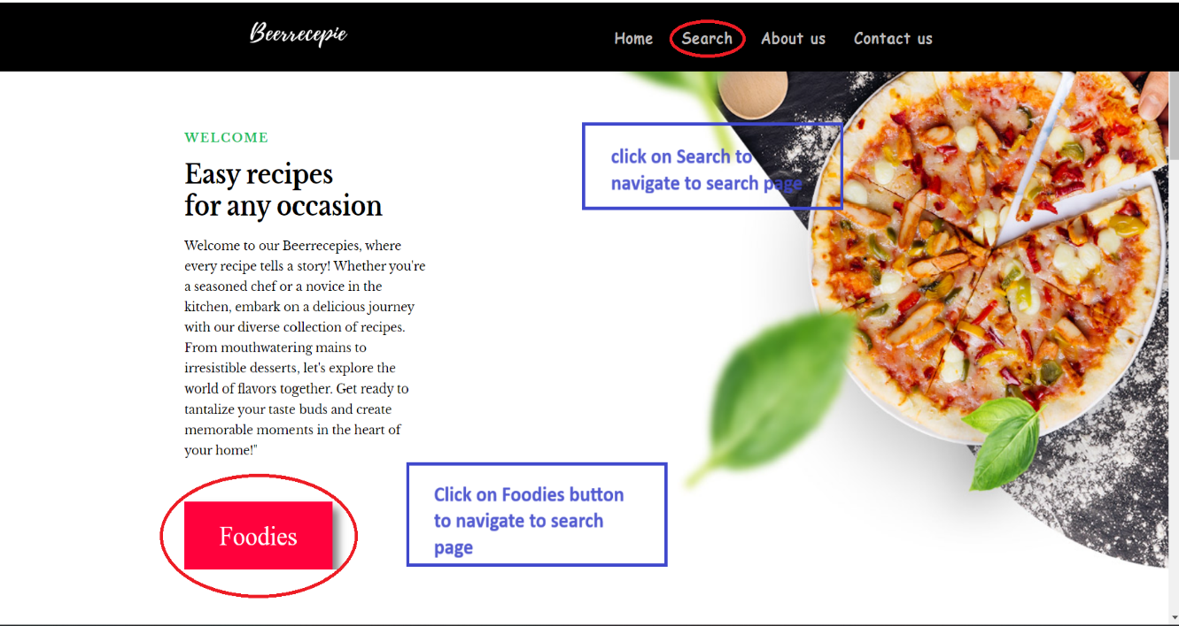

**Search Page**

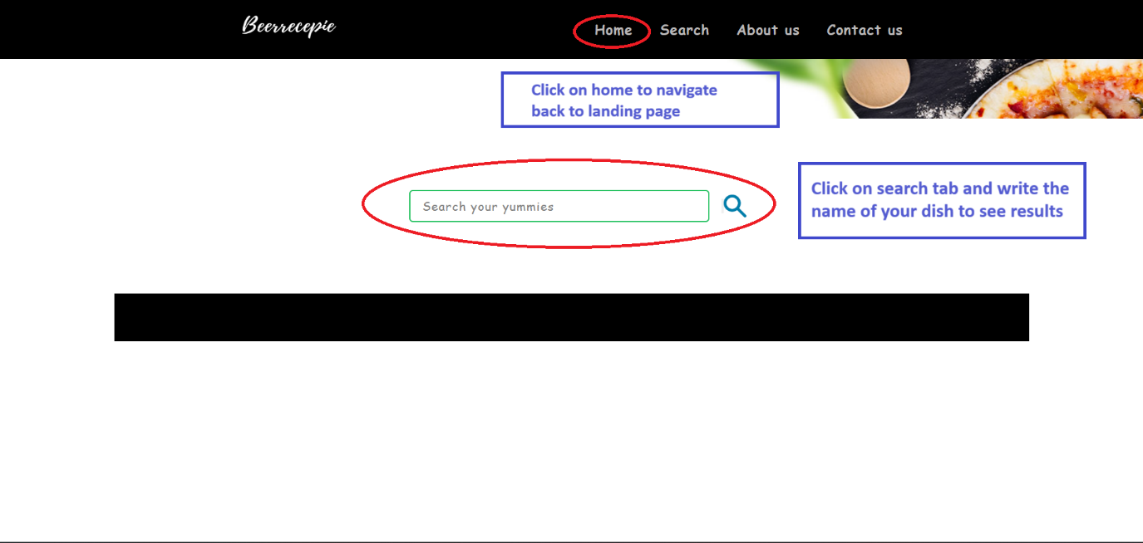

**Search results**

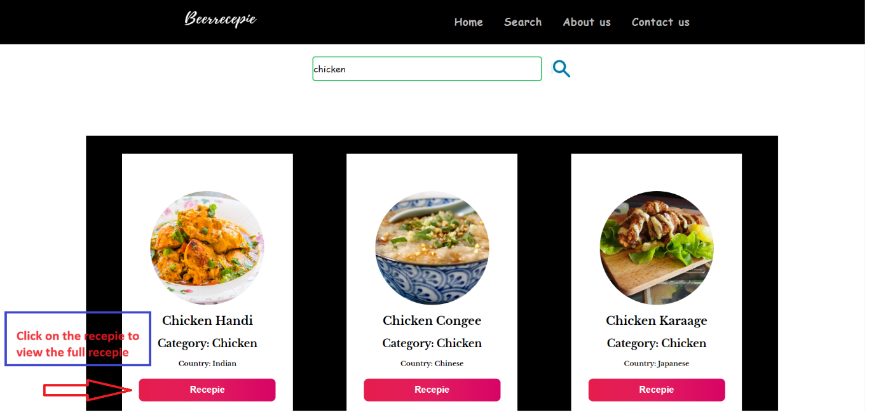

**Recipe and Instruction**

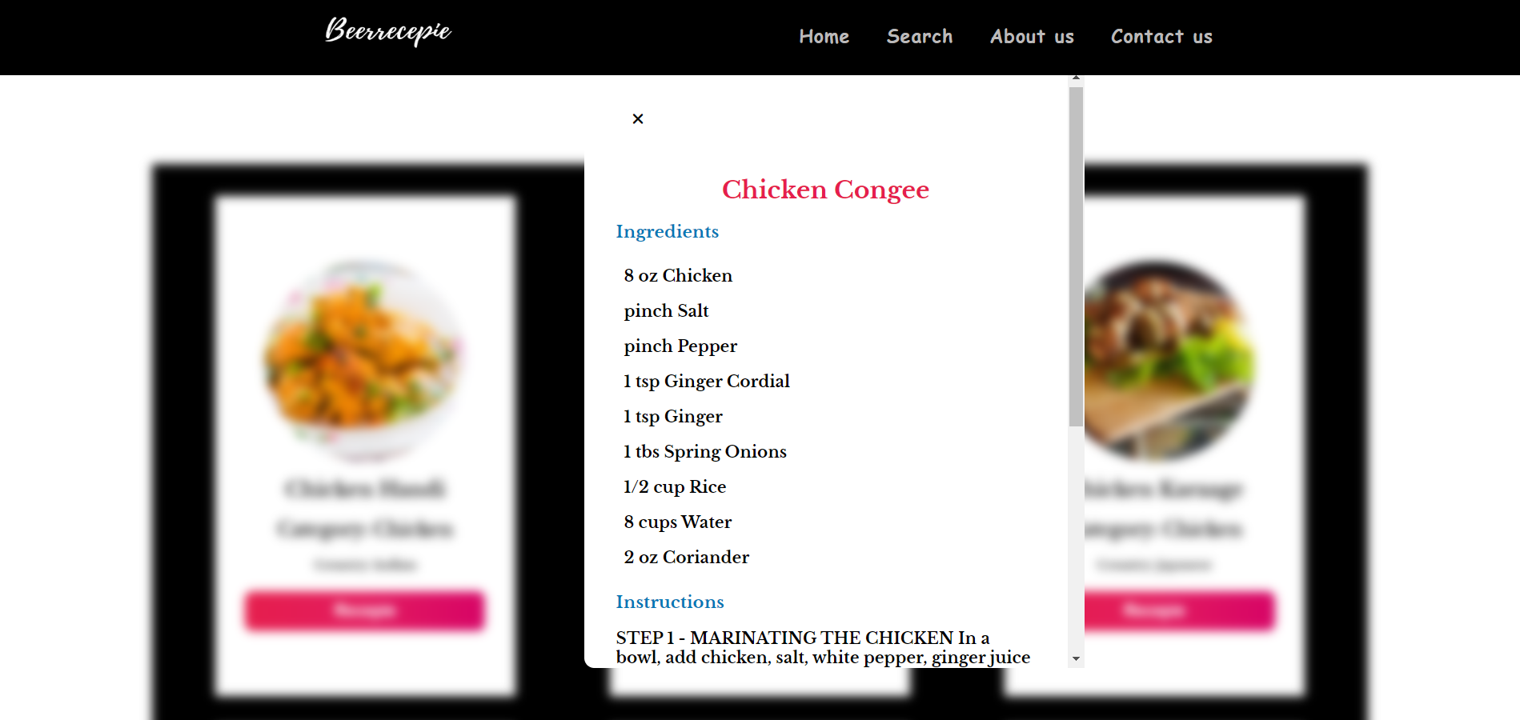

**About us page**

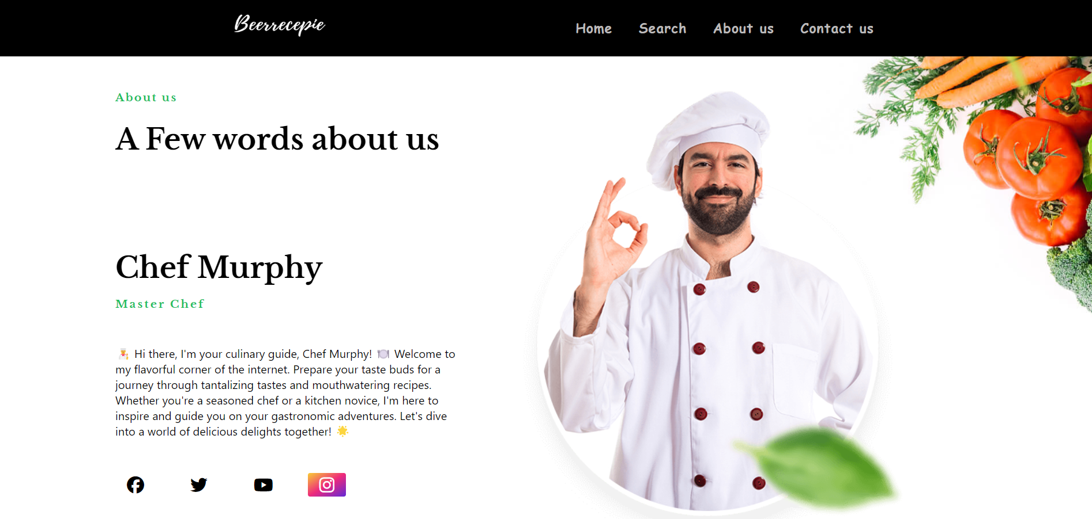

**11. Challenges and Solutions**

**Challenges Faced During Development:**

1. **API Integration Complexity:**
   * Working with external APIs, such as TheMealDB, presented challenges in understanding and effectively integrating the data into the website.
2. **Responsive Design Across Devices:**
   * Ensuring consistent and optimal user experience across various devices and screen sizes posed challenges due to differences in viewport dimensions and device capabilities.
3. **Handling Asynchronous Operations:**
   * Dealing with asynchronous operations in JavaScript, such as API requests and DOM manipulation, required careful handling to prevent race conditions and ensure data integrity.
4. **Cross-Browser Compatibility:**
   * Ensuring compatibility and consistent rendering across different web browsers presented challenges due to variations in browser rendering engines and CSS support.

**Solutions Implemented to Overcome Challenges:**

1. **Thorough Documentation and Research:**
   * Extensive documentation and research were conducted to understand the structure and endpoints of TheMealDB API, enabling effective integration into the website.
2. **Promises and Async/Await in JavaScript:**
   * Utilizing JavaScript Promises and Async/Await syntax facilitated the handling of asynchronous operations, ensuring sequential execution and better error handling.
3. **Iterative Development and Testing:**
   * Adopting an iterative development approach allowed for continuous testing and refinement of features, addressing issues as they arose and ensuring smoother progress.
4. **Community Support and Collaboration:**
   * Seeking help from online communities and collaborating with peers enabled the sharing of insights, solutions, and best practices, fostering a supportive development environment.

By employing these solutions and adopting a proactive approach to problem-solving, the development team successfully navigated challenges and delivered a robust, functional, and user-friendly Recipe Searching Website.

**12. Future Enhancements**

**Potential Features for Future Versions:**

1. **User Accounts and Personalization:**
   * Implement user authentication and account management functionalities, allowing users to create profiles, save favorite recipes, and create custom recipe collections.
2. **Social Sharing and Community Interaction:**
   * Enable users to share recipes on social media platforms and engage with other users through comments, ratings, and recipe reviews.
3. **Advanced Search Filters and Sorting Options:**
   * Enhance the search functionality with additional filters such as dietary restrictions, cooking time, difficulty level, and popularity rankings.
4. **Recipe Submission and Contribution:**
   * Allow users to submit their own recipes to be included in the database, fostering a community-driven platform for sharing culinary creations.

**Improvements and Refinements:**

1. **Performance Optimization:**
   * Continuously optimize website performance by minimizing load times, reducing server requests, and implementing caching strategies for static assets.
2. **Accessibility Enhancements:**
   * Improve accessibility compliance by enhancing keyboard navigation, ensuring proper semantic markup, and providing alternative text for images and other non-text content.
3. **Enhanced Data Visualization:**
   * Implement interactive charts and graphs to visualize nutritional information, allowing users to quickly assess the nutritional value of recipes at a glance.
4. **AI-Powered Recommendations:**
   * Incorporate machine learning algorithms to analyze user preferences and behavior, providing personalized recipe recommendations based on past
5. **Continuous Feedback Mechanism:**
   * Implement feedback loops to gather user feedback and suggestions for further improvements, ensuring that future iterations of the website align with user needs and preferences.

### 13. Conclusion

**Summary of the Project:**

The Recipe Searching Website is a dynamic and user-friendly platform designed to help users discover and explore a wide variety of recipes from around the world. Built using HTML, CSS, and JavaScript, and leveraging TheMealDB API for recipe data, the website provides users with an intuitive interface to search for recipes, view detailed recipe information, and enhance their culinary experience. Key features include robust search functionality, responsive design, and seamless integration with external recipe databases.

**Lessons Learned:**

Throughout the development process, several valuable lessons were learned:

1. **Effective API Integration:** Working with external APIs requires thorough understanding and careful integration to ensure seamless data retrieval and presentation.
2. **Importance of Responsive Design:** Prioritizing responsive design is crucial to providing a consistent and user-friendly experience across various devices and screen sizes.
3. **Iterative Development Approach:** Adopting an iterative development approach allows for flexibility and adaptability, enabling continuous improvement based on user feedback and evolving requirements.
4. **User-Centric Design:** Putting the needs and preferences of users at the forefront of design decisions is essential for creating a successful and engaging website.

**Final Thoughts:**

The Recipe Searching Website project has been an enriching journey, combining technical skills with creativity and user-focused design principles. By providing users with a valuable resource for discovering and exploring new recipes, the website aims to inspire culinary exploration and creativity in the kitchen. Moving forward, the project will continue to evolve, incorporating user feedback and implementing new features to further enhance the user experience and make cooking more enjoyable and accessible for all.

**15. References**

1. TheMealDB API Documentation: https://www.themealdb.com/api.php
2. MDN Web Docs (Mozilla Developer Network) for HTML, CSS, and JavaScript: https://developer.mozilla.org
3. Bootstrap Documentation for Responsive Design: https://getbootstrap.com/docs
4. Stack Overflow for Community Support and Troubleshooting: https://stackoverflow.com
5. W3Schools for Tutorials and Reference Materials: https://www.w3schools.com
6. CSS-Tricks for CSS Tips, Tricks, and Techniques: https://css-tricks.com
7. JavaScript.info for JavaScript Tutorials and Insights: https://javascript.info

These references and resources were instrumental in guiding the development process, providing valuable insights, tutorials, and tools to overcome challenges and create a successful Recipe Searching Website.